Minikube Setup on Windows Pro/Enterprise

These instructions are for setting up and installing Minikube and its dependencies for use on Windows Pro or Enterprise with Docker Desktop and HyperV

**Step involved.**

1. **Install kubectl on the local desktop**
2. **Install Minikube client on the local desktop**
3. **Configure and Enable HypverV on the win 10 pro local desktop**
4. **Starting Up Minikube on the VM**
5. **Information about the setup**
6. **Login and manage the minikube VM.**

**Step1: Install Kubectl**

1. Create a new directory that you will move your kubectl binaries into. A good place would be C:\bin
2. Download the latest kubectl executable from the link on the Kubernetes doc page:

<https://kubernetes.io/docs/tasks/tools/install-kubectl/#install-kubectl-on-windows>

1. Move this downloaded .exe file into the bin directory you created.
2. Use Windows search to type “env” then select “Edit the system environment variables”

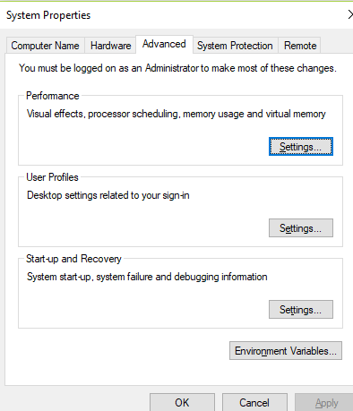

Click on “Environment Variables”

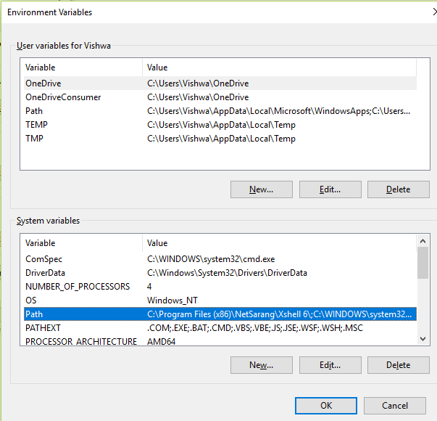

Select “**Path**” under the **“System Variables”** and click on **“Edit”**

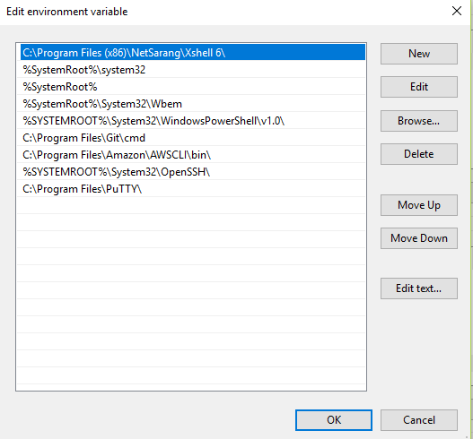

Click on “New” to add the Kube path in which we can downloaded the kubectl.

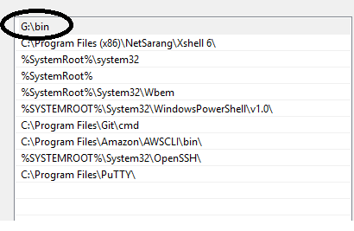

Drag the newly created path so that it is higher in order than Docker's binaries. This is very important and will ensure that you will not have an out of date kubectl client.

Click "OK"

 Restart your terminal and test by typing kubectl into it. You should get the basic commands and help menu printed back to your screen. If this doesn't work try restarting your machine.

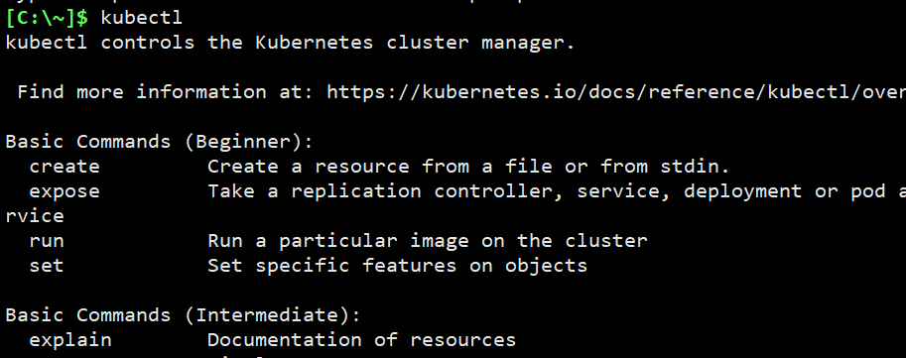

Run kubectl version to verify that you are using the newest version and not the out of date v1.10 version

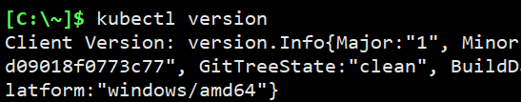

**Step2: Install Minikube client on the local desktop**

1. Download the Windows installer here:

<https://github.com/kubernetes/minikube/releases/latest/download/minikube-installer.exe>

2. Double click the .exe file that was downloaded and run the installer. All default selections are appropriate.

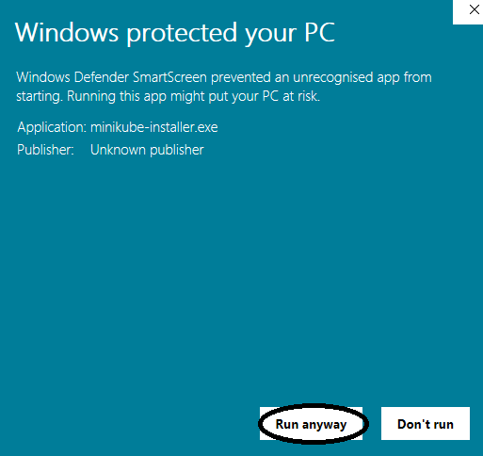

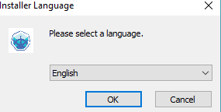

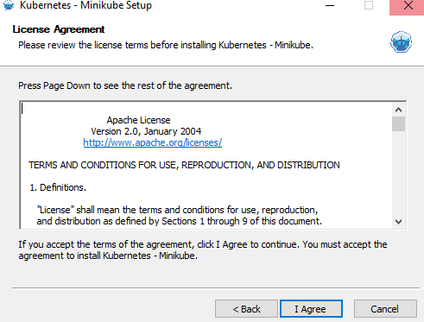

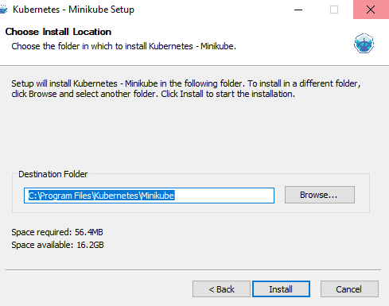

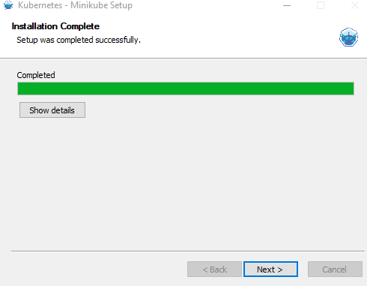 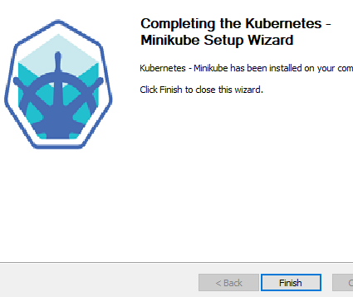

3. Open up your terminal and test the installation by typing minikube. You should get the basic commands and help menu printed back to your screen. If this doesn't work try restarting your machine.

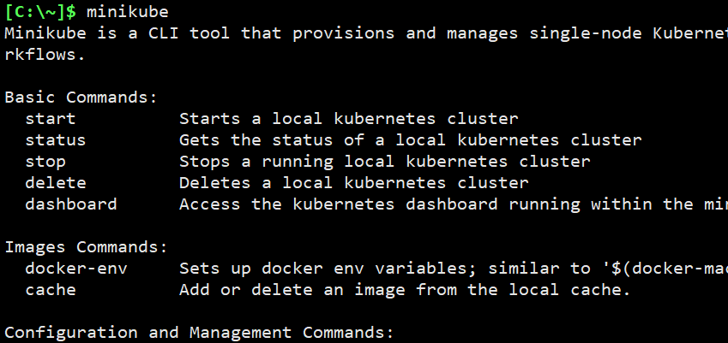

**Step3:**

#### **Configure HyperV**

Note: -- this is for windows 10 pro only.

If your system is other version of os, use “virtualbox” instead.

1. Install the HyperV first

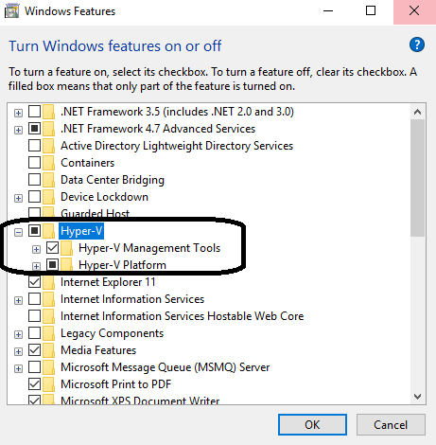

Click on “**OK**”

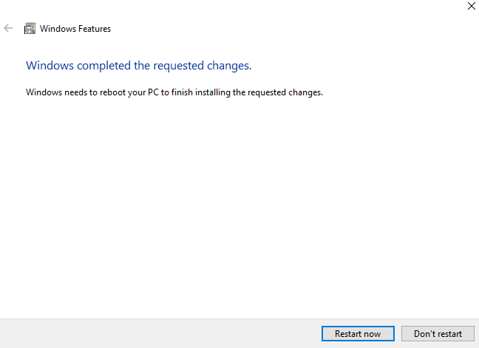Click on **Restart Now**.

1. In Windows Search type "HyperV" and select "HyperV Manager"

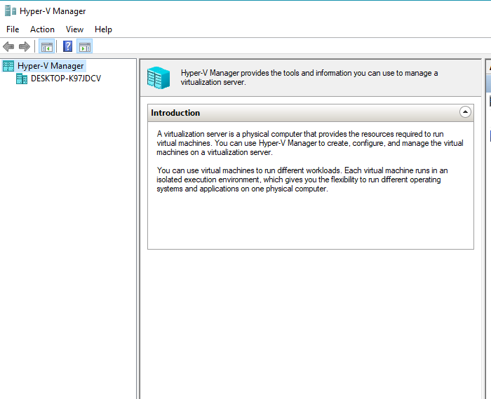

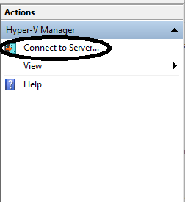First lets, enable the local hyper manager.

Click on “Connect to server”

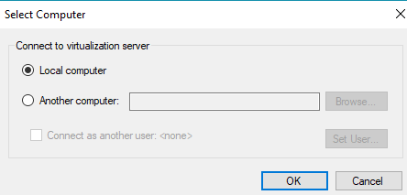

Select “Local Computer” and Click “OK”

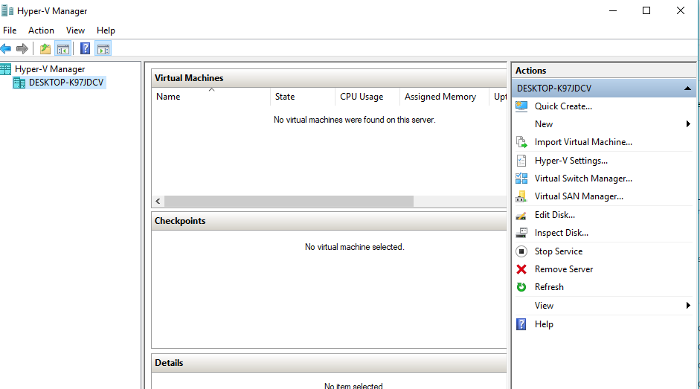

1. In the right sidebar click "Virtual Switch Manager"

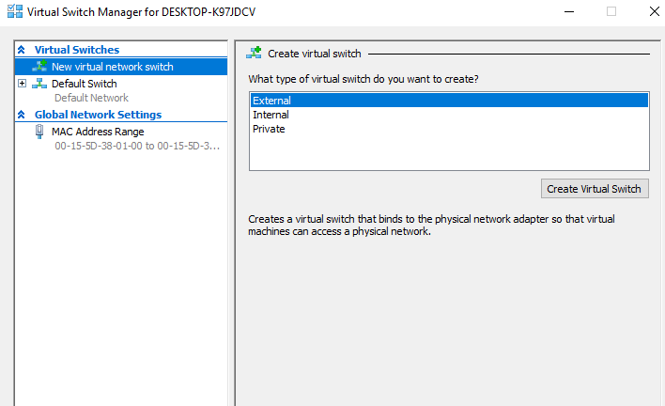

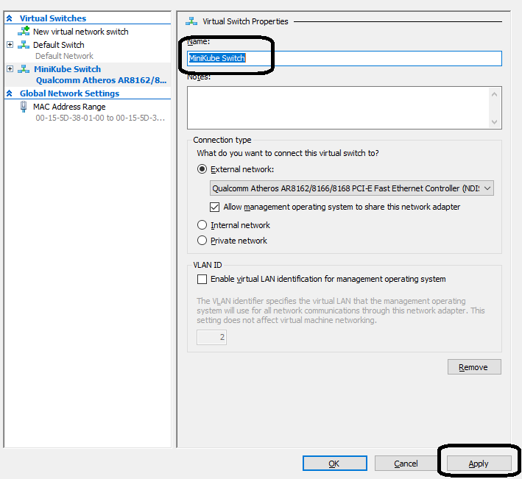

Click Apply and acknowledge the "Pending changes" dialog box by clicking "yes".

Once the switch has been created, click "Ok"

**Step4: *Starting Up Minikube on the VM***

#### Since by default Minikube expects VirtualBox to be used, we need to tell it to use the hyperv driver instead, as well as the Virtual Switch we created earlier.

Start up a terminal as an Administrator. Then, in your terminal run:

Important note, all minikube commands must be run in the context of an elevated Administrator.

The Above command is going to download the basic ISO images for minikube env to run

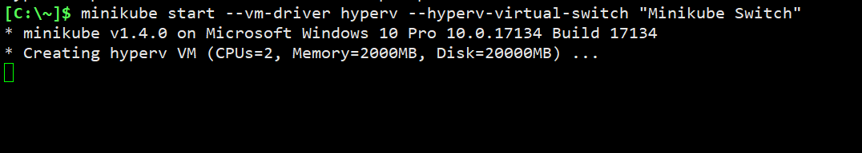

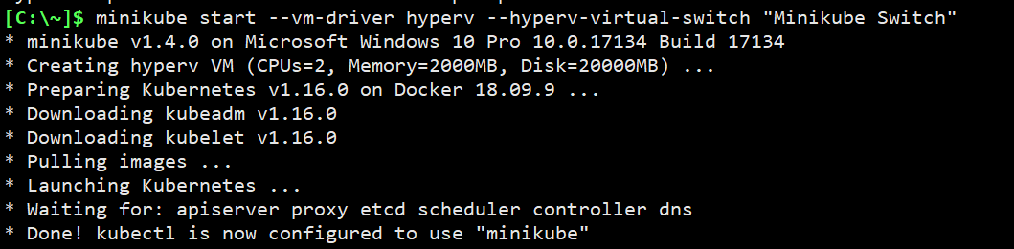

**Step5: Information about the setup**

**$ minikube status**

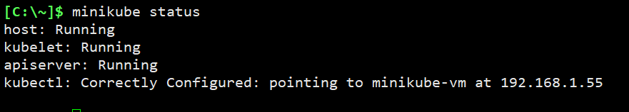

**$ kubectl cluster-info**

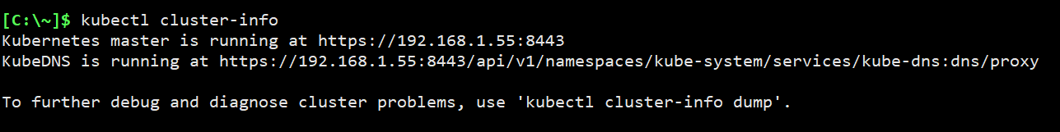

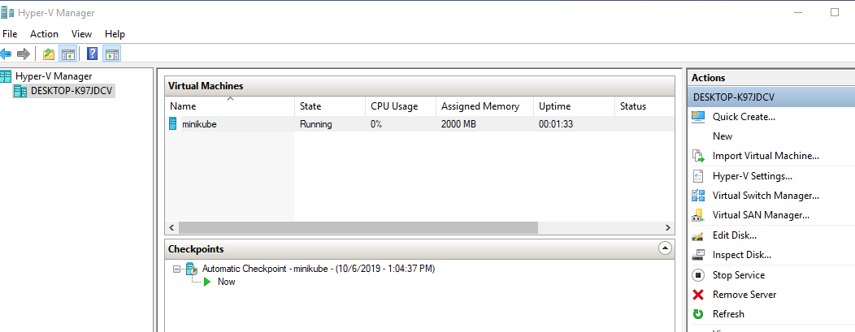

**Step6:** To Login to the minikube cluster VM

$ minikube ssh

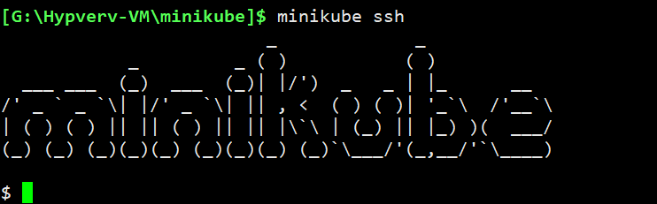

To Stop the minikube VM,

**Note**: -- **DON’T TRY TO STOP THE VM DIRECTLY FROM THE HYPERV CONSOLE, BETTER DO IT FROM MINIKUBE COMMAND**

The below should be run from your desktop and NOT FROM inside the minikube VM.

C:\> minikube stop

